Issue 1 :Full Mother’s Maiden Name is not displayed when we try to create order though API
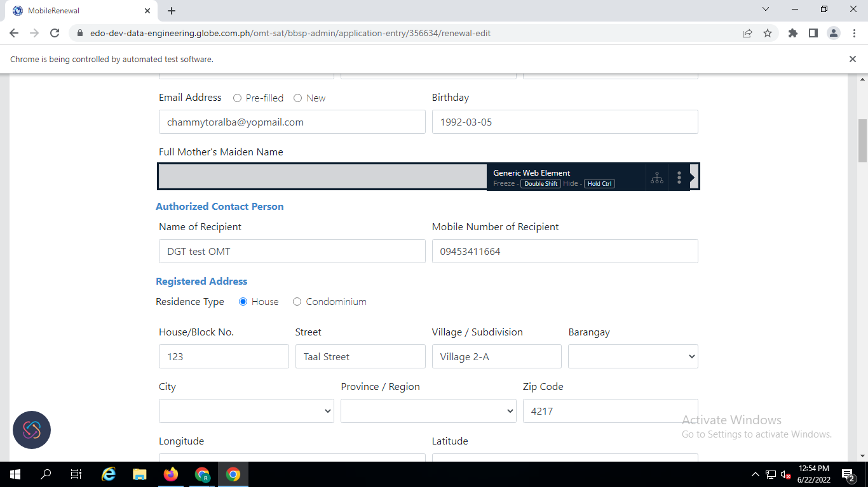

Issue 2 :Date Reviewed Is not displaying or not auto populated
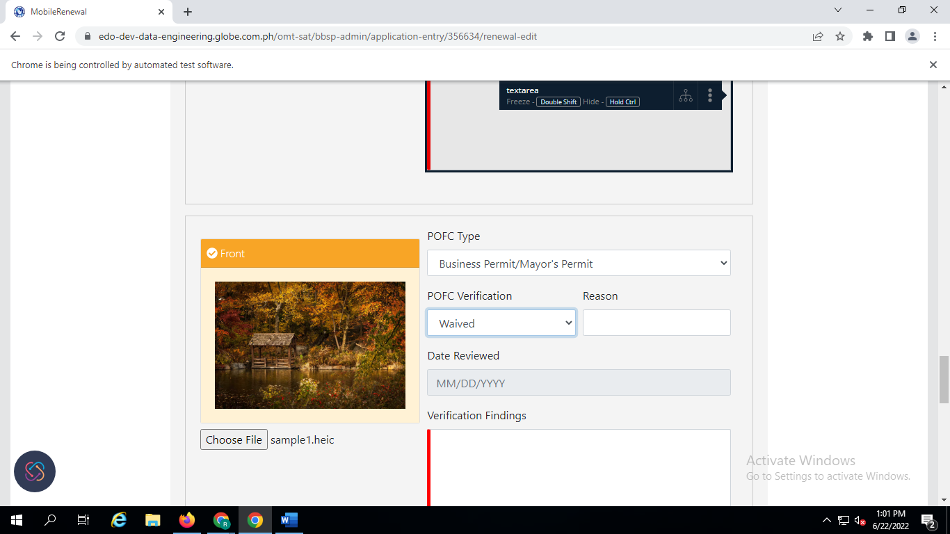

Issue 3 :View More is not displayed after updating the Verification findings
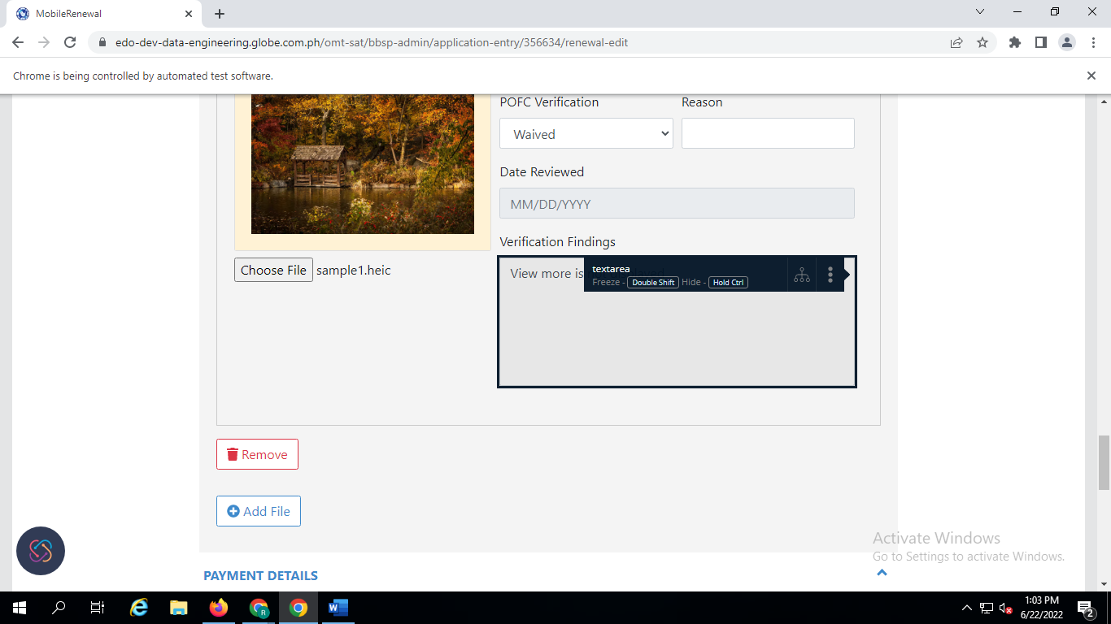

Confirmation - Even when the documents are uploaded the findings for the previous entry is mandatory
- And after saving POID and POFC the POID details are updated with the updated one and POFC is displaying both
- Should be able to validate that the current value for Verification Findings will be cleared out

Issue 4 :Images are not displaying after saving and images are broken

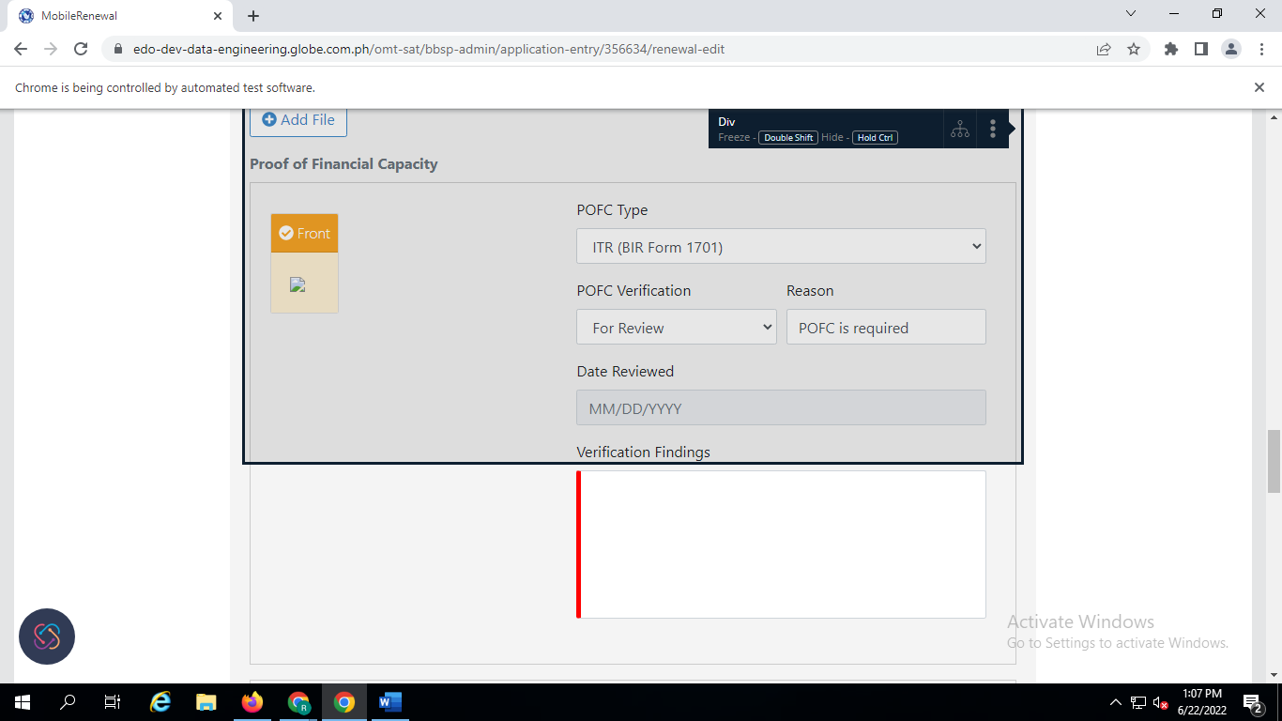
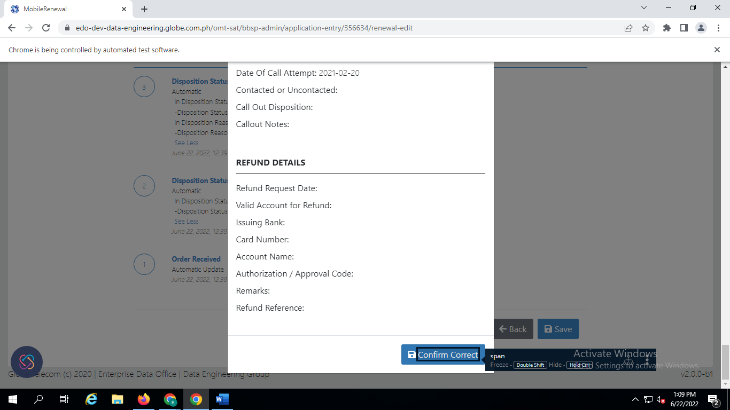

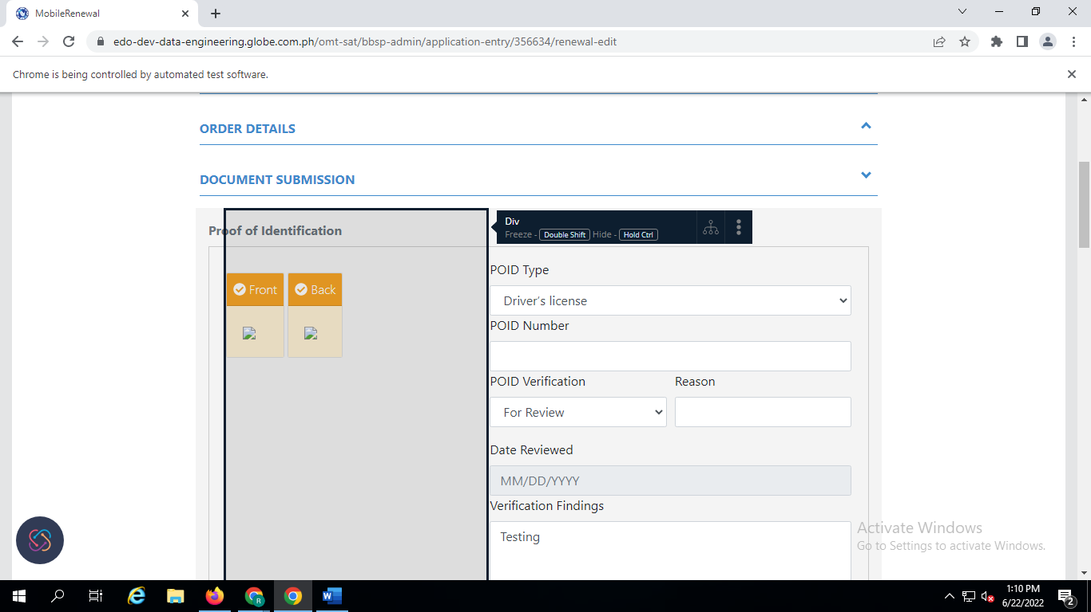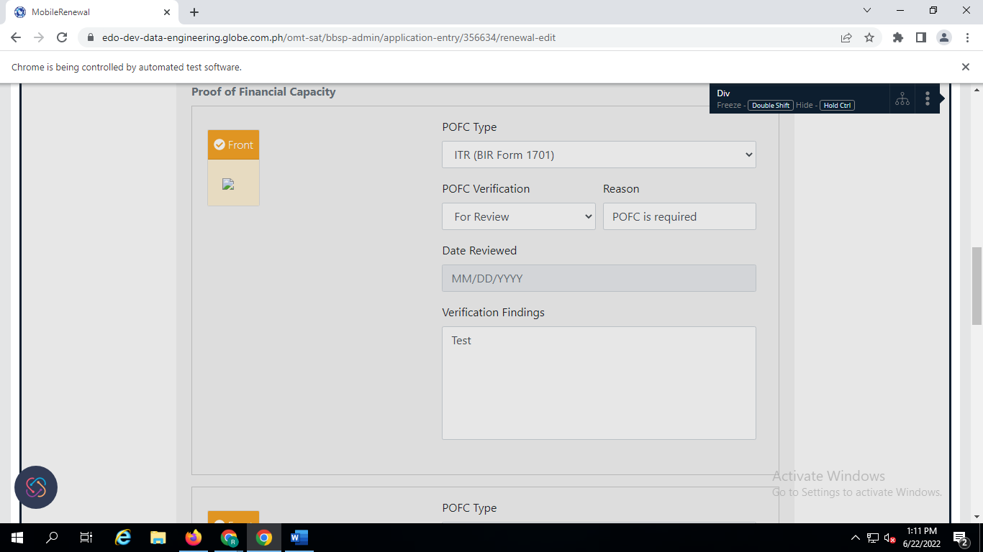
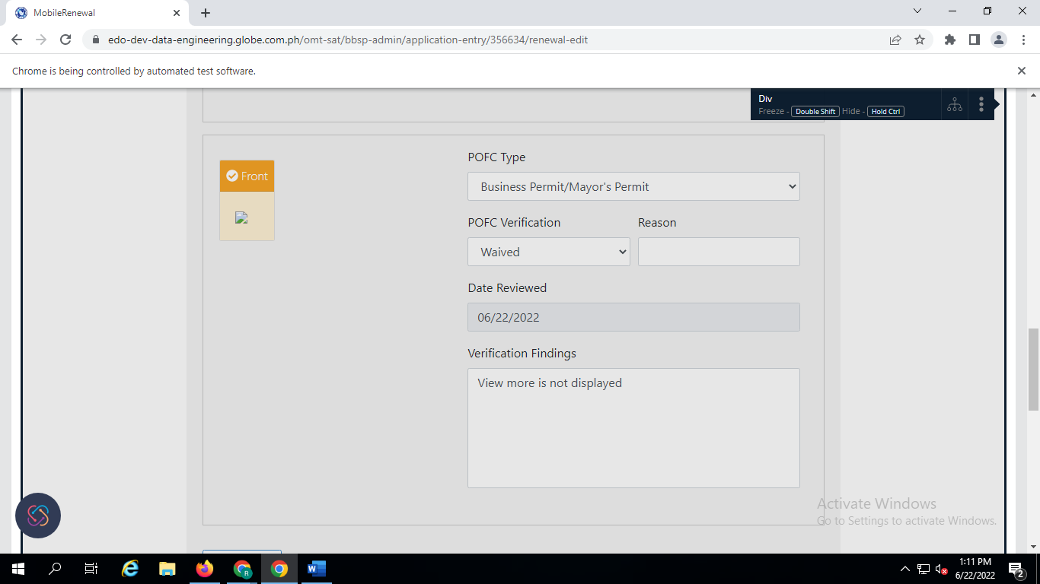

Issue 5 : Previous Verification Findings: ,Previous Date Reviewed: Fields above are not updated or displayed when we try to save the date in POID and POFC details in verification history
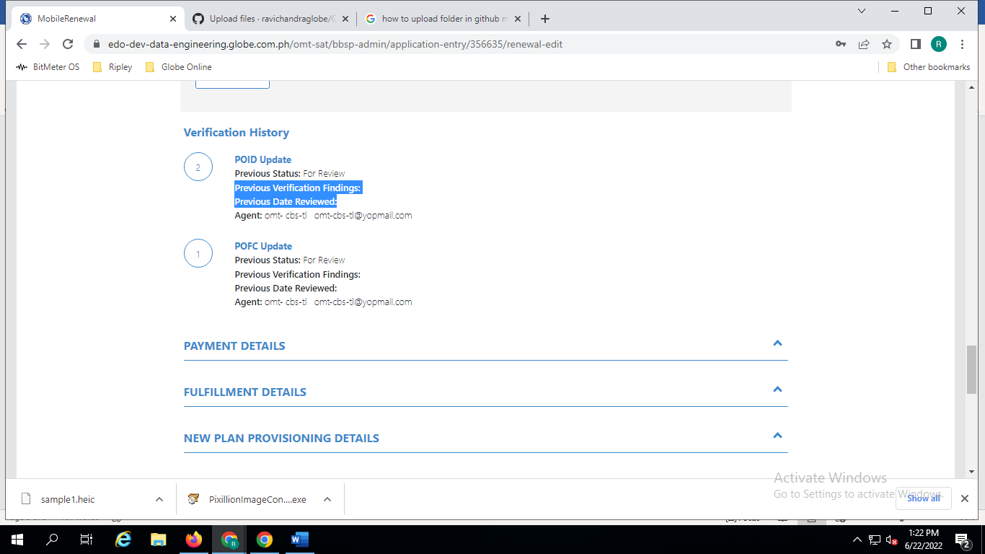
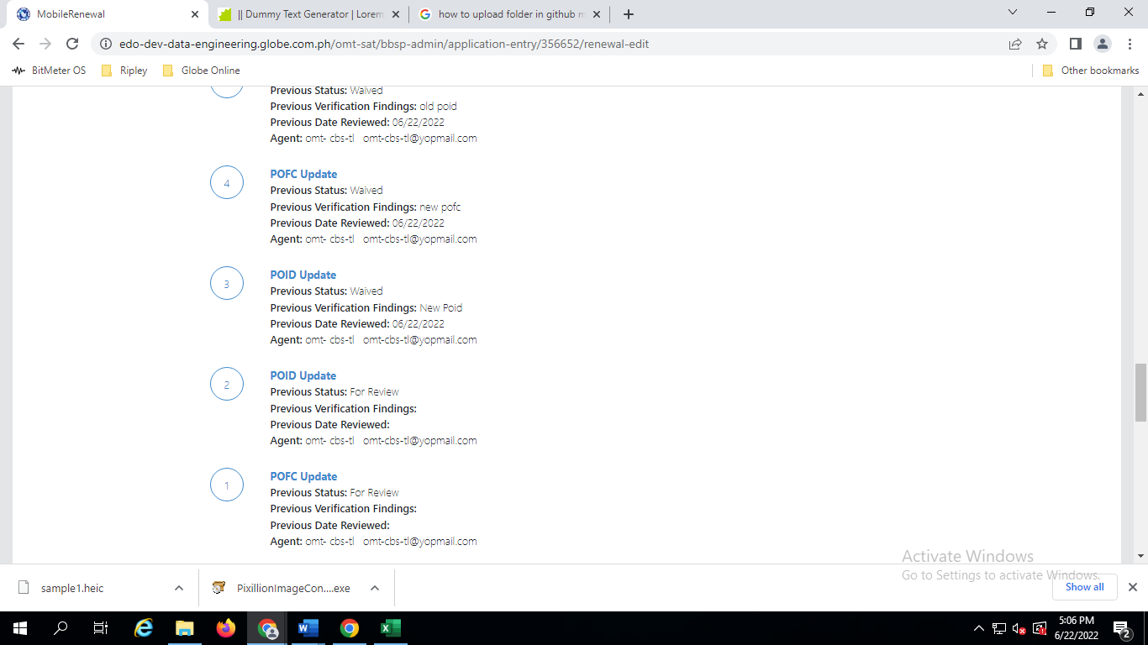

Issue 6 : POID and POFC Verification Findings in the Verification History exceeded 250 characters including spaces and able to save the changes

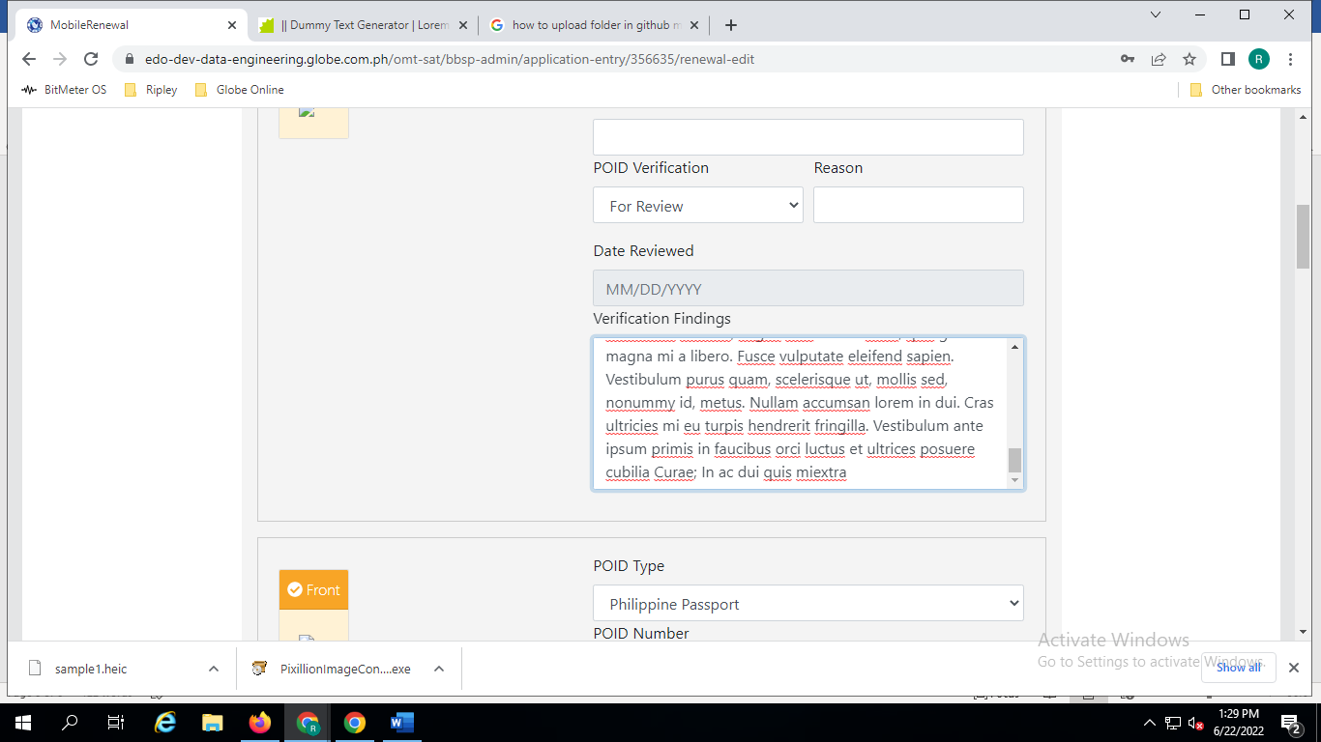
Duplicate: "View More" hyperlink is not displayed
